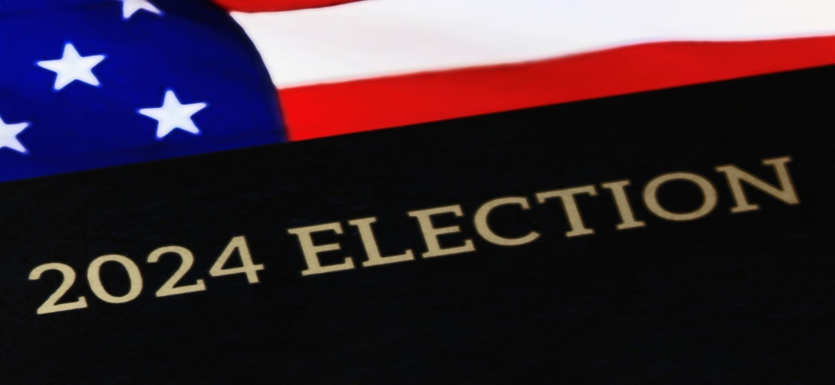

QUALIFYING PERIOD BEGINS ON: AUGUST 02,2024 @ 8:00AM
QUALIFYING PERIOD ENDS ON: AUGUST 23,2024 @ 3:00 PM
CANDIDATE PETITIONS FOR VERIFICATION: JULY 12, 2024 @ 3:00 PM
REQUIRED NUMBER OF VALID PETITION SIGNATURES NEEDED IS 20

SEATS UP FOR ELECTION 2024:

FIRE COMMISSIONER

WATER WASTEWATER COMMISSIONER

TOWN ZONING DEPARTMENT

IMPORTANT LINKS FOR CANDIDATES:

https://www.votenassaufl.gov/

https://www.votenassaufl.gov/candidate-dashboard

https://dos.fl.gov/elections/contacts/frequently-asked-questions/faq-candidates

https://dos.fl.gov/elections/forms-publications/forms/

SUPERVISOR OF ELECTIONS:
Phone: 904-491-7500
Toll Free: 1-866-260-4301
Fax: 904-432-1400
Email: info@votenassaufl.gov
James S. Page Governmental Complex
96135 Nassau Place, Suite 3
Yulee, FL 32097

