6raL%07*2n7Z$jS8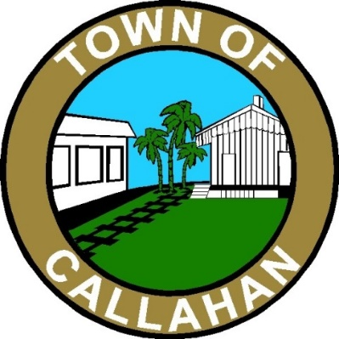
“The Crossroads to the Future”
Town Council Meeting Agenda
April 5, 2021 ** 7:00 PM

Attorney interviews: 6 pm – 7pm

Robert J. Grimaldi 6 pm

Christian W. Waugh 6:30 pm

- Call to Order

- Pledge of Allegiance to Flag & Invocation

- Visitors Welcomed & Reminded Meeting Minutes are Being Recorded

- Persons Wishing to Address Council – 3 Minute Limit

- Minutes

- Joint Meeting with School Board March 15, 2021
- March 15, 2021
- March 29, 2021

- Treasurer’s Report

- Business

- Marilyn Armstrong on Billboard
- Agreement with FDOT
- Resolution 2021-R03 FDOT
- Fireworks with Hilliard/ Proposal from Firework Company
- Approval of New Attorney

- Review & Approval of Town Expenditures

- General Fund
- Weeks of March 18th, March 25th, April 1st

- Water & Sewer Fund
    - Weeks of March 18th, March 25th, April 1st

- Water & Sewer Adjustments

- Water & Wastewater Disbursements

- Around the Council Table

- Adjourn

If a person decides to appeal any decision made by the board, agency, or commission with respect to any matter considered at such meeting or hearing, he or she will need a record of the proceedings, and that, for such purpose, he or she may need to ensure that a verbatim record of the proceedings is made, which record includes the testimony and evidence upon which the appeal is to be based.

