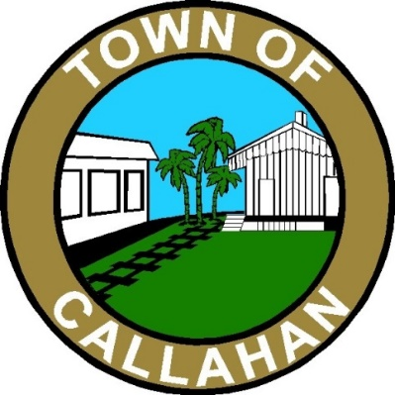
“The Crossroads to the Future”
Town Council Special Meeting Agenda
March 29, 2021 ** 7:00 PM

- Call to Order

- Pledge of Allegiance to Flag & Invocation

- Visitors Welcomed & Reminded Meeting Minutes are Being Recorded

- Persons Wishing to Address Council – 3 Minute Limit

- Business

- Internal Investigation of Employee

- Around the Council Table

- Adjourn

If a person decides to appeal any decision made by the board, agency, or commission with respect to any matter considered at such meeting or hearing, he or she will need a record of the proceedings, and that, for such purpose, he or she may need to ensure that a verbatim record of the proceedings is made, which record includes the testimony and evidence upon which the appeal is to be based.

